

**Project Title: COOKAI: TRANSFORMING INGREDIENTS INTO RECIPE**

**Group Members:**

1. Member 1- N. Sai Priya (2022BCSE07AED323)
2. Member 2- U. C Pravallika (2022BCSE07AED228)
3. Member 3 - G. Sinchana (2022BCSE07AED129)

**Date of Submission:** 28-10-2024

**Table of Contents**

**Description** **Page no.**

1. **Introduction** 01
2. **Problem Statement** 02
3. **Workload Matrix** 03
4. **Literature Review** 03
5. **Data Collection** 04
6. **Data Preprocessing** 05
7. **Model Development** 08
8. **Model Evaluation** 09
9. **Conclusion** 12
10. **References** 12
11. **Appendices *(if any)*** 13
12. **Project Presentation** 13

**1. Introduction:**

In recent years, people cook at home and experiment with different cuisines, there has been an increase in demand for quick, dependable, and easily accessible recipe information in recent years. The project "COOKAI: Transforming Ingredients into Recipes" aims to simplify the cooking process by giving users a precise ingredient list and a detailed step-by-step guide based on the recipe name they provide. The goal of this project is to make recipes easier to find so that users may cook with confidence and ease.

**Objective of the Project:**  
COOKAI's main goal is to develop a recipe retrieval system that:

* Provides consumers with a precise ingredient list and comprehensive preparation instructions based on the recipe name they enter.
* Minimizes confusion caused by disparate internet sources by guaranteeing consistency and dependability in recipe results.
* Enhances the cooking process by giving rapid access to organized easily navigable recipe material.

**Scope of the Project:**

* Gathering and analyzing a large dataset of recipes from many cuisines and meal categories.
* Creating code that can reliably fetch recipes and connecting it to an intuitive user interface.
* Ensuring a smooth integration that improves meal preparation convenience and user accessibility.

**2. Problem Statement:**

Developing a recipe recommendation system that offers precise, user-friendly suggestions based on available ingredients and dietary preferences poses significant challenges. Many existing recipe platforms lack personalization, often leading to an overload of irrelevant or unsuitable recipe options for users. This issue is further complicated by inconsistent ingredient measurements, varying preparation steps, and limited filtering options for specific dietary requirements or ingredient availability. Moreover, individuals with limited cooking experience may struggle to explore new recipes or substitute ingredients effectively without guided support.

1. **Workload Matrix:**

|  |  |  |  |
| --- | --- | --- | --- |
| **Task** | **Team member** | **Duration** | **Description** |
| Data collection | All team members | 3 days | Collecting recipe data from various sources (Kaggle). |
| Model | N. Sai Priya | 4 days | Designing and training model |
| Report | U.C Pravallika | 2 days | Compiling finding and documentation for final project. |
| Presentation | G. Sinchana | 1 day | Creating and finalizing presentation project demonstration. |

1. **Literature Review:**

* Machine Learning based Recipe Recommendation System:

Recommender systems, which help users find relevant information within large datasets, have proven useful in recipe recommendations by using user profiles and filtering technologies. User preferences are essential to successful recommendations, particularly for personalizing recipes. Prior research compares two primary approaches: item-based and user-based filtering. The item-based approach uses Tanimoto Coefficient Similarity and Log Likelihood Similarity to find recipe similarities, while the user-based approach applies Euclidean Distance and Pearson Correlation to measure alignment between users’ tastes. Enhanced with fixed-size and threshold-based neighborhood techniques, the user-based approach demonstrated better performance, especially when applied to the all recipe dataset, which has a high volume of user interactions. Various machine learning models, such as collaborative filtering and hybrid approaches, are commonly used for recommendation tasks, with deep learning techniques showing promise in improving recommendation accuracy. These approaches and findings provide a basis for enhancing recipe retrieval systems like COOKAI.

* Recipe Recommendation System based on automatic nutrition information extraction:

In recent years, a variety of machine learning approaches have been explored to enhance recipe recommendation systems, particularly those that leverage nutritional information to cater to specific dietary goals. Prior research has introduced models capable of retrieving recipes tailored to users' health needs, incorporating user-friendly, goal-oriented search features. For instance, a goal-oriented recipe recommendation system was developed to allow users to search for recipes that support specific health conditions by using natural language, even if they have limited nutritional knowledge. The system facilitated queries such as "I want to cure my acne" or "I want to recover from my fatigue" by analyzing the nutritional components of recipes. Existing machine learning models in recipe recommendation often use NLP (Natural Language Processing) to interpret user intentions and ingredient or nutrient-based data processing for recipe recommendations. Models like collaborative filtering, content-based filtering, and hybrid approaches have also been utilized, each with different performance outcomes depending on dataset structure and user preference handling.

* A Cooking Recipe Recommendation System with Visual Recognition of Food Ingredients:

In the development of recipe recommendation and retrieval systems, various machine learning approaches have been explored to enhance the user experience in recipe discovery. Prior research has implemented techniques like natural language processing (NLP), computer vision, and recommendation algorithms to simplify meal planning and ingredient identification. These systems aim to provide users with reliable and contextually appropriate recipes based on ingredient input, whether typed or visually recognized. One notable approach involves a recipe recommendation system designed for consumer smartphones, which employs real-time visual object recognition to identify food ingredients directly via the device’s camera. This system allows users to point their smartphone camera at ingredients, enabling immediate recipe suggestions based on the recognized items. The system achieves a high recognition rate of 83.93% within the top six candidates and can identify 30 types of ingredients in just 0.15 seconds, demonstrating its efficiency in real-world applications. User studies have confirmed the effectiveness of this visual recognition model, especially in assisting users at grocery stores or in kitchens when deciding on recipes.

[1] Citation: Vivek, M.B., Manju, N., Vijay, M.B. (2018). Machine Learning Based Food Recipe Recommendation System. In: Guru, D., Vasudev, T., Chethan, H., Kumar, Y. (eds) Proceedings of International Conference on Cognition and Recognition . *Lecture Notes in Networks and Systems, vol 14. Springer, Singapore. https://doi.org/10.1007/978-981-10-5146-3_2*

[2] Citation: Ueta, T., Iwakami, M., Ito, T. (2011). A Recipe Recommendation System Based on Automatic Nutrition Information Extraction. In: Xiong, H., Lee, W.B. (eds) Knowledge Science, Engineering and Management. KSEM 2011. *Lecture Notes in Computer Science(), vol 7091. Springer, Berlin, Heidelberg. https://doi.org/10.1007/978-3-642-25975-3_8*

[3] Citation: Yanai, K., Maruyama, T., & Kawano, Y. (2014). A Cooking Recipe Recommendation System with Visual Recognition of Food Ingredients. *International Journal of Interactive Mobile Technologies*, *8*(2).

**5. Data Collection**

**Data Source:**  
The dataset consists of 80 recipes, each containing details across four columns:

**Name**: The name of the dish, serving as an identifier for each recipe.

**Ingredients**: A list of ingredients required to prepare the dish, including main components and seasonings.

**Procedure**: Step-by-step instructions for preparing the recipe, providing guidance from start to finish.

**Serving**: A brief description of serving suggestions or typical occasions for each dish.This dataset provides a structured framework for linking recipe names to their ingredients and preparation methods, enabling efficient recipe retrieval and user-friendly presentation in the COOKAI application

**Data Description:**  
The dataset used for the COOKAI project contains 80 entries, each representing a unique recipe. It has four features that provide essential details for generating accurate recipe retrievals:

**Name**: This feature contains the recipe name, which serves as the primary input for users to search for a recipe. This feature is key for identifying and linking recipes in the system.

**Ingredients**: A list of all ingredients required for each recipe, specifying the components needed to prepare the dish. This feature is essential for returning accurate ingredient lists to users and could be further processed for ingredient categorization.

**Procedure**: Step-by-step cooking instructions for each recipe, guiding users through the preparation process. This feature helps ensure clarity and consistency in recipe output, enhancing user experience.

**Serving**: Provides serving suggestions or suitable occasions for the dish. This feature could add context and personalization to recipe recommendations in future iterations.

**Dataset Summary:**

**Size**: 80 entries

**Number of Features**: 4

**Target Variable**: The **Name** feature functions as the target, as it links user input to the recipe details (Ingredients and Procedure) generated by COOKAI.

1. **Data Preprocessing**

* **Handling Missing Values:**  
  Handling Missing Values: In the dataset if there are missing values in the dataset, we need to fill which are represented as NaN, Blank space etc. So, to fill the missing values their different ways to fill.
* 1. By deleting the rows. df.dropna()
* 2. By imputation methods like: Mean, Median, Mode

df.fillna(df.mean(), inplace=True)

df.fillna(df.median(), inplace=True)

df[column].fillna(df[column].mode()[0], inplace=True)

3. Interpolation Techniques df.interpolate(method='linear', inplace=True) df.interpolate(method='quadratic', inplace=True)

**Loading dataset:**

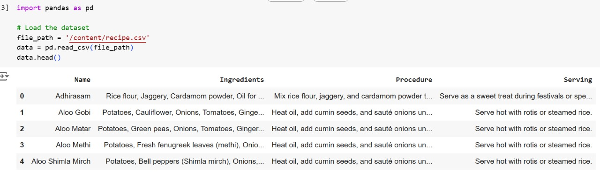

**Removing duplicates:**

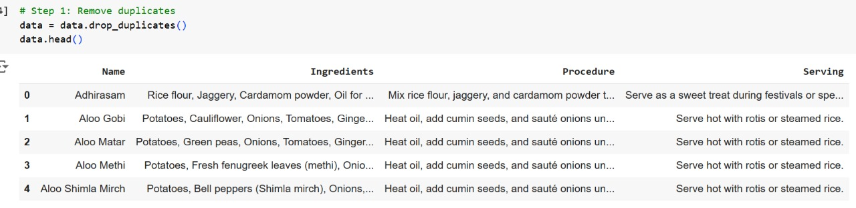

**Handling missing values:**

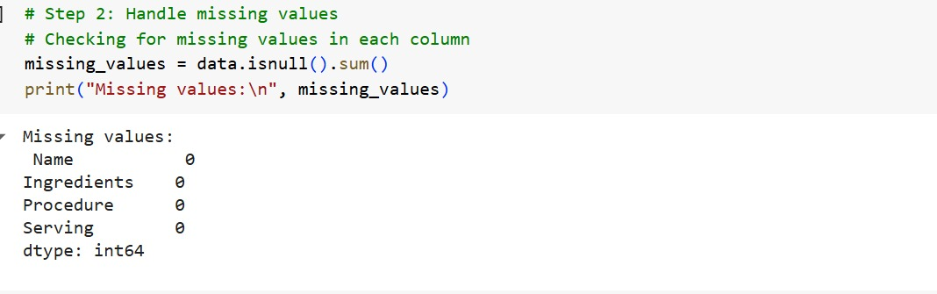

**Standardizing Ingredients:**

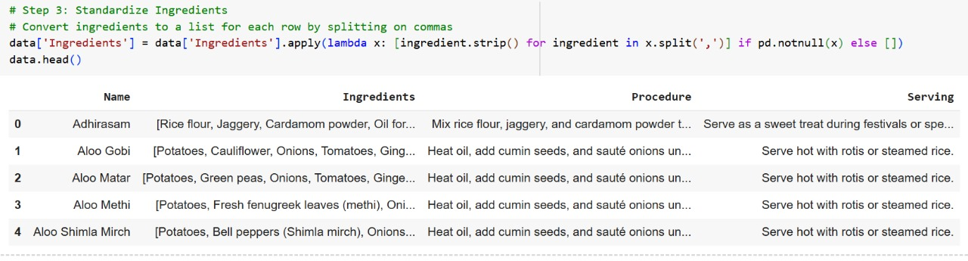

**Cleaning text columns:**

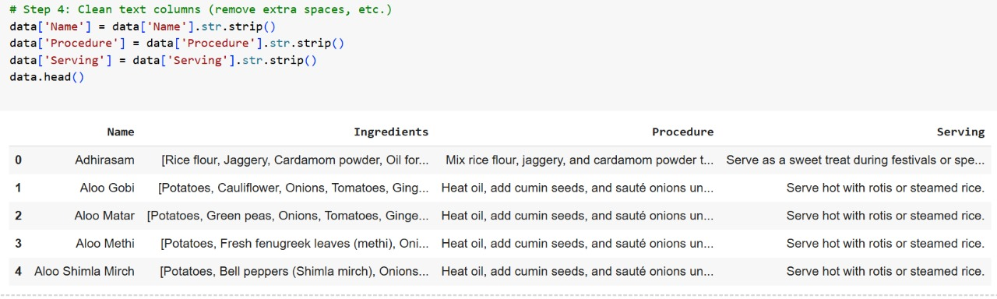

**First few rows of the preprocessed data:**

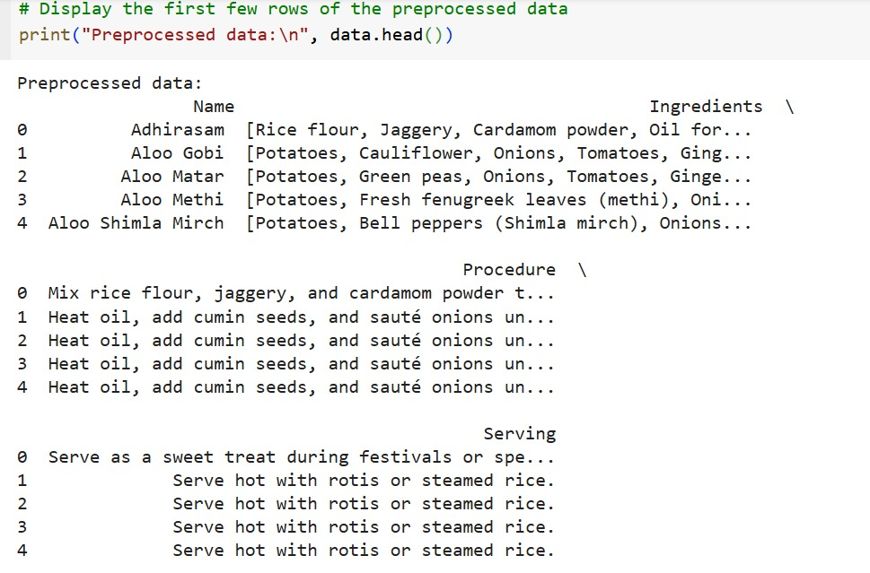

1. **Model Development (2-3 models)**

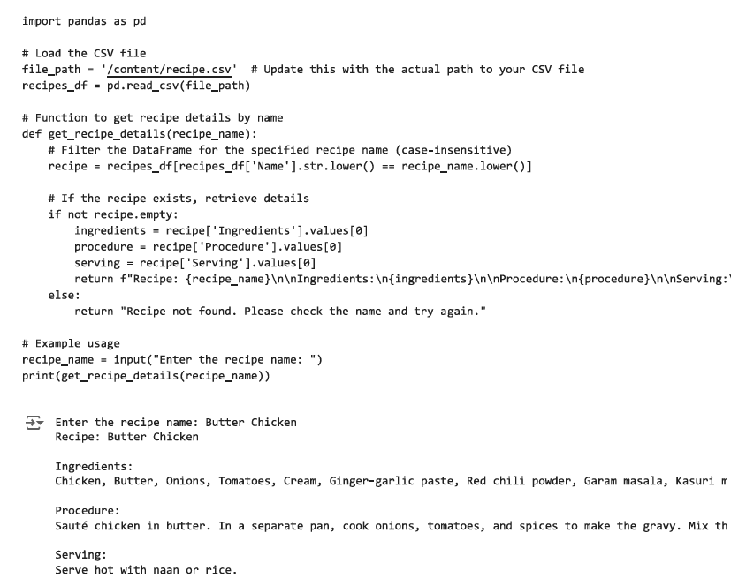

**8. Model Evaluation**

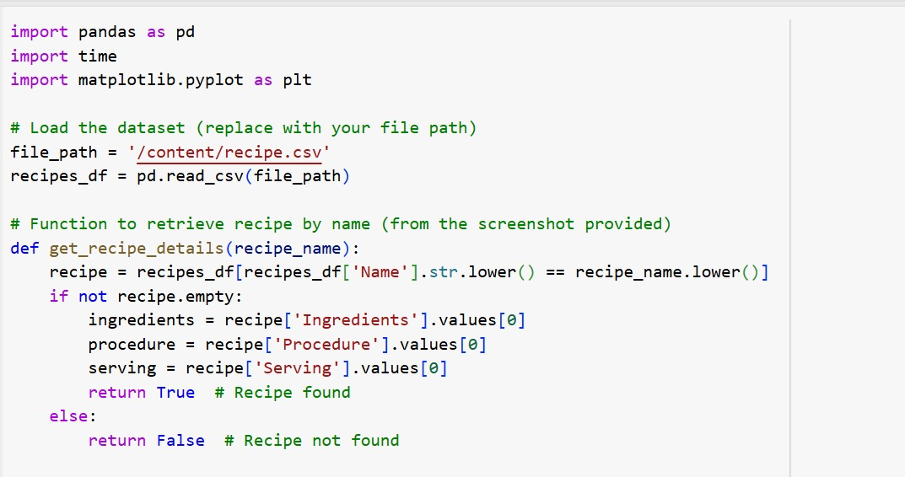

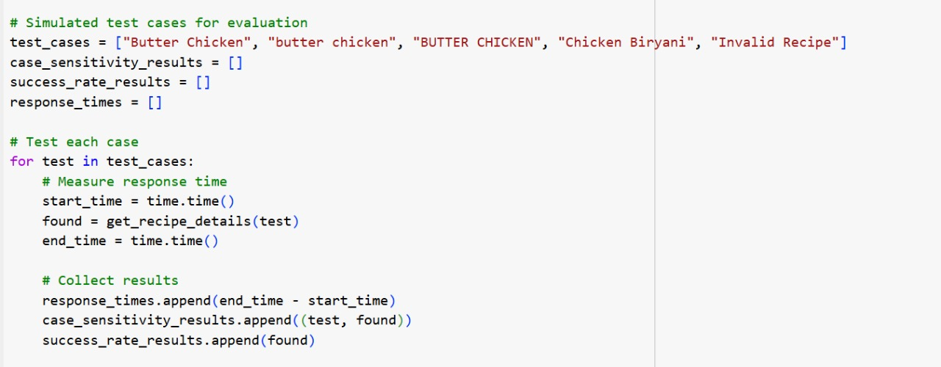

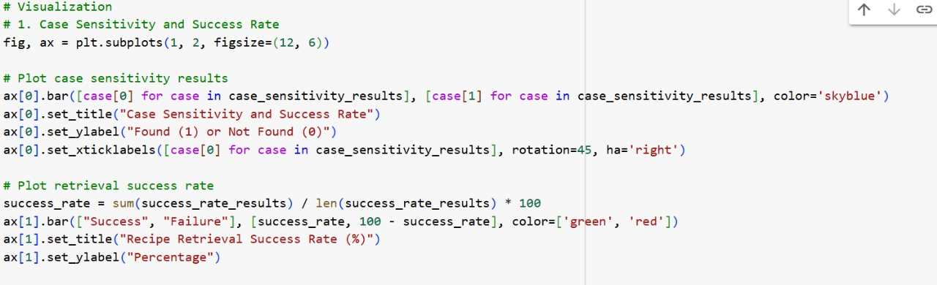

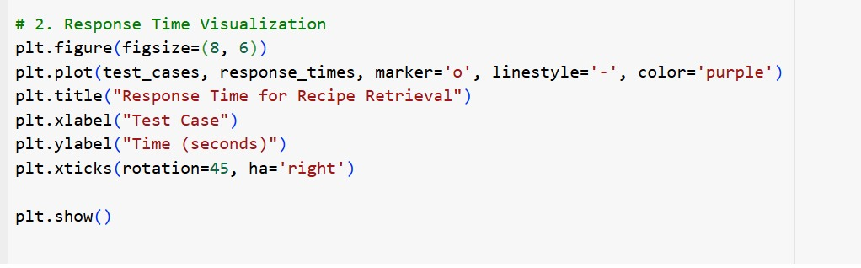

Output:

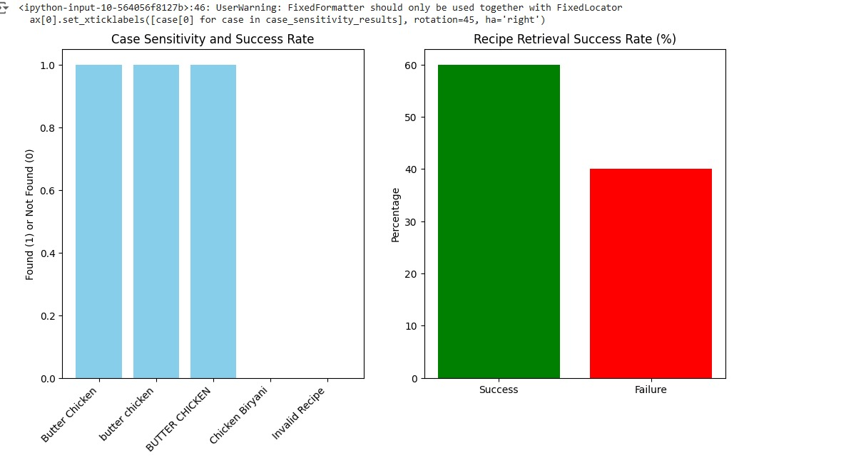

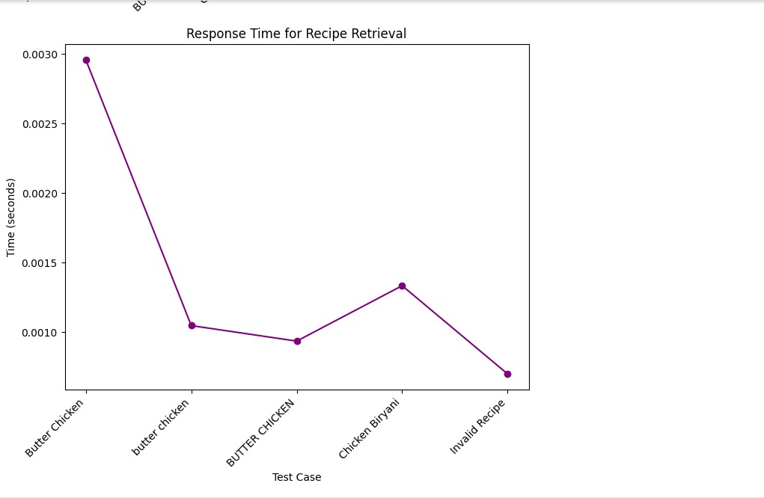

**9. Conclusion**

The COOKAI project addresses a common problem in online recipe retrieval by providing users with a standardized list of ingredients and detailed cooking instructions for any specified recipe. Through the integration of a structured dataset and a user-friendly interface, COOKAI simplifies the cooking process by offering consistent, reliable recipes at the user's request. By resolving inconsistencies in online recipe information, COOKAI not only enhances the cooking experience but also contributes to the development of intuitive, AI-driven applications in the culinary field. This project paves the way for future improvements, such as incorporating ingredient substitution options, nutritional information, and multi-language support, to broaden its accessibility and utility for a global audience**.**

**10. References**

1. Vivek, M.B., Manju, N., Vijay, M.B. (2018). Machine Learning Based Food Recipe Recommendation System. In: Guru, D., Vasudev, T., Chethan, H., Kumar, Y. (eds) Proceedings of International Conference on Cognition and Recognition . Lecture Notes in Networks and Systems, vol 14. Springer, Singapore.

2. Ueta, T., Iwakami, M., Ito, T. (2011). A Recipe Recommendation System Based on Automatic Nutrition Information Extraction. In: Xiong, H., Lee, W.B. (eds) Knowledge Science, Engineering and Management. KSEM 2011. Lecture Notes in Computer Science(), vol 7091. Springer, Berlin, Heidelberg.

3. Rodrigues MS, Fidalgo F, Oliveira Â. RecipeIS—Recipe Recommendation System Based on Recognition of Food Ingredients. *Applied Sciences*. 2023; 13(13):7880.